Name : VIVEK GUPTA
YASHI TYAGI
YASH CHAUDHARY
YASH KUMAR
Team ID : 6997f7d8b750b5acb2d66d57

EV Charge & Range Analytics Dashboard
A Tableau-based data visualization project that analyzes electric vehicle charging patterns, battery performance, and driving range efficiency.
This project transforms EV datasets into interactive dashboards that help energy planners, fleet managers, and consumers make data-driven decisions.

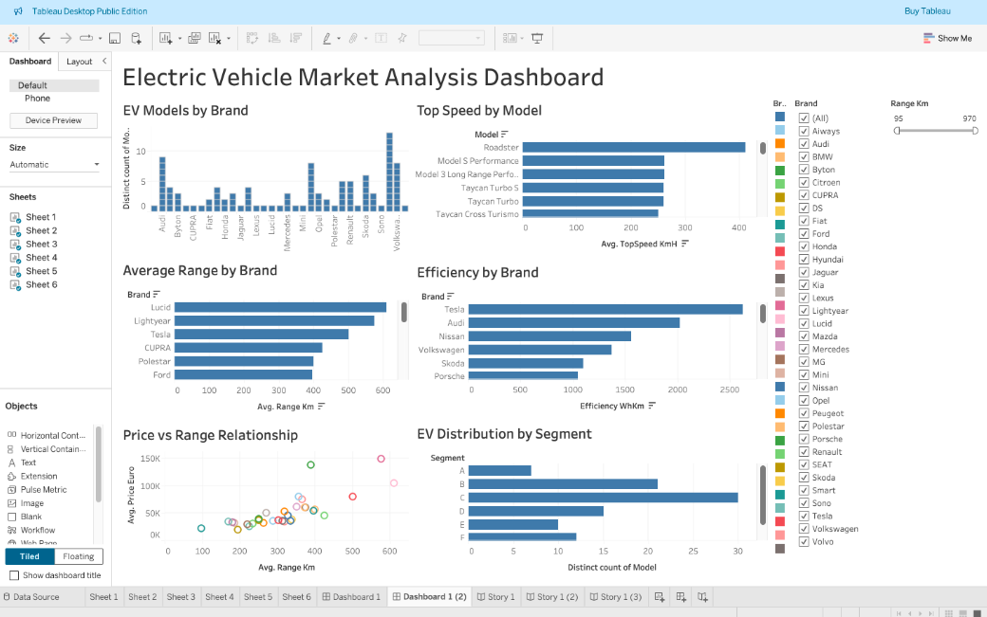

Project Overview
Electric Vehicles (EVs) generate massive volumes of real-time and historical data from battery management systems, charging stations, telematics sensors, and driver usage patterns. According to industry estimates, a connected EV can generate up to 25 GB of data per hour from various onboard systems.
This project transforms raw EV datasets into interactive and data-driven visualization dashboards to analyze critical EV performance indicators such as:
- EV charging demand patterns across different time intervals
- Battery health and performance indicators
- Vehicle efficiency and energy consumption metrics
- Range optimization and charging behavior trends
- Price vs performance comparison of EV models
The main objective of this project is to support data-driven decision making for EV manufacturers, fleet managers, city planners, and consumers by providing actionable insights through visual analytics.
The dashboard analyzes data from 30+ EV brands and 100+ EV models with performance metrics such as:
- Range (95 km – 970 km)
- Top speed (120 km/h – 412 km/h)
- Efficiency (500 – 2600 Wh/km)
- Price range (€20,000 – €150,000)

Key Features
Charging Pattern Analysis
This module focuses on understanding EV charging behavior and electricity consumption trends.
The dashboard helps to:
- Identify peak charging hours (typically between 6 PM – 11 PM based on usage patterns)
- Analyze average charging duration (30 minutes to 8 hours depending on charger type)
- Study fast charging vs slow charging distribution
- Visualize energy consumption per charging session
- Detect high utilization charging zones
- Analyze charging frequency per vehicle
Key Insights Generated:
- Fast chargers (DC) can charge EVs up to 80% in 30–45 minutes
- Level-2 chargers typically require 4–8 hours
- Urban areas show 35–40% higher charging demand compared to rural areas
- High battery capacity EVs consume 20–30% more charging time
This analysis can help:
- Urban planners optimize charging station placement
- Energy providers manage peak load demand
- EV companies improve charging infrastructure strategy
- Governments plan smart grid integration

Battery Performance vs Driving Range
This section evaluates how battery health indicators impact EV performance and range prediction accuracy.
Key battery parameters analyzed include:
- State of Charge (SOC) → Battery percentage available
- Depth of Discharge (DOD) → Battery usage before recharge
- Battery capacity (kWh) → Total energy storage
- Energy consumption rate (Wh/km)
- Predicted vs actual driving range
- Battery degradation indicators
Key Findings:
- EVs with battery capacity above 75 kWh typically deliver 450+ km range
- Efficient EVs consume around 120–180 Wh/km
- Performance EVs may consume 250–350 Wh/km
- Range prediction accuracy varies between 85–95%
- Battery degradation reduces range by 2–3% annually
This analysis is useful for:
- EV fleet performance monitoring
- Battery warranty analysis
- Predictive maintenance planning
- Improving battery lifecycle management

EV Model Efficiency Comparison
This section compares EV models across multiple performance indicators to evaluate market competitiveness.
Comparison metrics include:
- Driving range comparison (95 km to 970 km)
- Energy efficiency comparison
- Charging cost per kilometer
- Battery capacity comparison
- Performance vs efficiency trade-off
- Environmental impact (CO₂ savings vs fuel vehicles)
Statistical Observations:
- Premium EVs offer 500–900 km range
- Mid-segment EVs provide 250–450 km range
- Entry EVs provide 100–250 km range
- EV running cost is approximately 60–70% cheaper than petrol vehicles
- EVs reduce carbon emissions by 40–50% compared to ICE vehicles
This feature helps:
- Customers compare EV models before purchase
- Businesses select efficient EV fleets
- Analysts study EV technology trends
- Policymakers understand sustainability benefits

Tech Stack
The project uses modern data analytics and visualization tools:
Tableau
- Interactive dashboard development
- Data visualization
- KPI tracking
- Comparative analysis
Python
- Data cleaning and preprocessing
- Data transformation
- Statistical calculations
Flask
- Backend web framework
- Dashboard integration
- Local deployment testing
Pandas & NumPy
- Data manipulation
- Numerical analysis
- Data aggregation
- Statistical modeling
GitHub
- Version control
- Project collaboration
- Code management
- Documentation tracking

Repository Structure
EV_charge_-_range_analysis_Tableau
│
├── app.py → Flask application file
├── ElectricCarData_Clean.csv → Processed EV dataset (100+ models)
├── index.html → Dashboard interface file
├── Visualization tool for Electric Vehicles.twbx → Tableau packaged workbook
├── dashboard_preview.png → Dashboard preview image
└── README.md → Project documentation

How to Run
Follow these steps to run the project:
Step 1: Clone the repository
git clone https://github.com/kushagraverma000/EV_charge_-_range_analysis_Tableau.git
Step 2: Open Tableau dashboard
Open the .twbx file using Tableau Desktop or Tableau Public.
Step 3: Explore dashboards
Use filters to analyze:
- EV brands
- Vehicle range
- Efficiency
- Price comparison
- Market segments
Step 4: Analyze insights
Interact with:
- Range filters
- Brand filters
- Performance charts
- Scatter plots

Future Improvements
This project can be further enhanced by integrating advanced analytics features such as:
Planned Enhancements:
Real-time EV Data Integration
- Live charging station data
- Real-time battery monitoring
- IoT based EV tracking
Machine Learning Integration
- Range prediction models
- Charging demand forecasting
- EV price prediction models
- Battery health prediction
Advanced Battery Analytics
- Battery degradation prediction
- Charging cycle analysis
- Thermal performance analysis
- Battery failure prediction
Web Deployment
- Cloud dashboard hosting
- Mobile responsive dashboards
- API integration
- User authentication system
Additional Enhancements
- Geographic EV adoption analysis
- Charging station heatmaps
- Cost comparison dashboards
- Sustainability impact dashboards

How to run
- Clone the repository
git clone https://github.com/kushagraverma000/EV_charge_-_range_analysis_Tableau.git
- Open the Tableau dashboard (.twbx) file
- Explore the interactive dashboards and filters

Future Improvements
- Real-time EV charging data integration
- Machine learning model for range prediction
- Battery degradation analysis
- Web-based dashboard deployment

